PHYS 135A Activity 1

Connecting the ideas in distance (position)-time and velocity-time graphs: The graphical relation between position, velocity, and acceleration

Practice example 1- The graph below shows position as a function of time for two trains running on parallel tracks. Is there any point in time (as shown in the graph) where the two trains

- have the same velocity?

- have the same position?

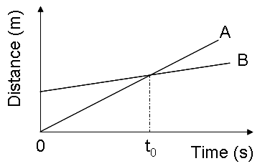

Practice example 2- Given the distance-time graph for a car as shown below, determine its velocity-time graph.

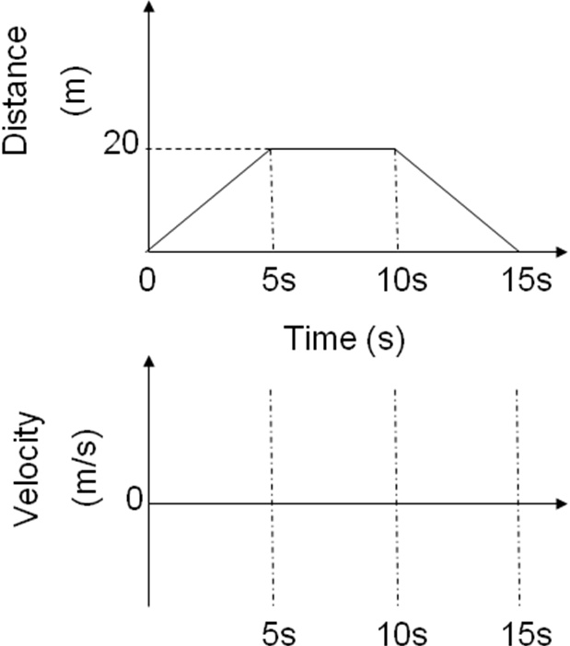

Practice example 3- Given the velocity-time graph for a car as shown below, determine its position-time graph.

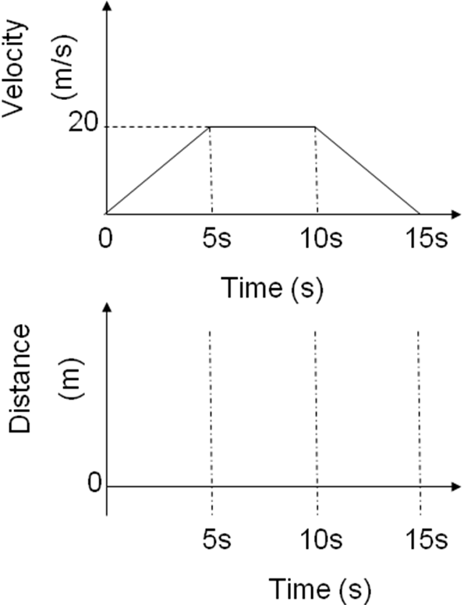

Practice example 4- Given the distance-time graph for a car as shown below, determine its velocity-time graph. Note: The curve in the last stage is quadratic in time.

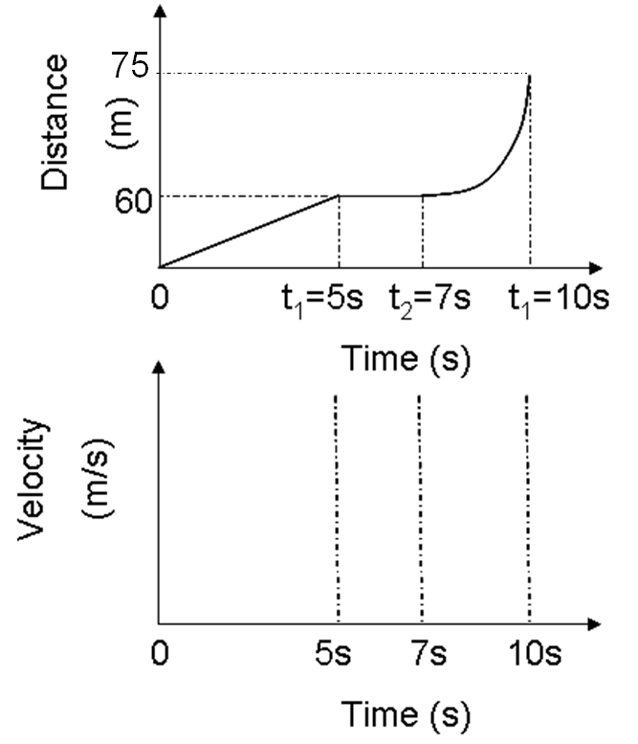

Conclusion:

1-) The slope in a distance-time graph is the velocity

2-) The area under the curve of a velocity-time graph is the displacement.

